30/5/2016 Greylag Goose 77, Shelduck 98 Findhorn Bay Gordon McMullins
30/5/2016 Great Northern Diver 2 off Lossiemouth (on the sea) Bob Proctor
30/5/2016 (15:30-16:55) Velvet Scoter 1, Red-throated Diver 1, Razorbill 21, Guillemot 10 past Lossiemouth in two half-hour watches Bob Proctor
30/5/2016 Glaucous Gull 1 (2nd winter) Hopeman east beach per Birdguides
30/5/2016 Swift 4 Braemoray (Edinkillie) Mike Crutch
29/5/2016 Cuckoo 1 Allanreid (Glenlivet NJ2324) David Law
29/5/2016 Red-legged Partridge 1 Achdregnie (Glenlivet NJ2424) David Law
29/5/2016 Redshank 2 pairs, Teal 1, Goosander 1 River Livet (NJ2623) David Law
29/5/2016 Golden Plover 2 Carn an t-Suidhe (NJ2626) David Law
29/5/2016 Stonechat 1 Glen Suie (NJ2724) David Law
29/5/2016 Wood Warbler 1 singing Whiteash Hill Wood (NJ3658) Martin Cook
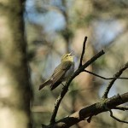
Wood Warbler, Whiteash Hill Wood 29 May 2016 (Martin Cook)
28/5/2016 Woodcock 1 roding Broom of Moy Ian Bailey
28/5/2016 Wood Warbler 1 singing Whiteash Hill Wood (NJ3658) Moray Bird Club outing
28/5/2016 (09:00) Little Egret 1 Cloddach gravel pit (NJ2060) David Main
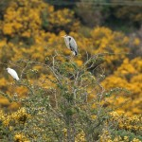
Little Egret with Grey Heron, Cloddach gravel pit 28 May 2016 (David Main)
28/5/2016 Fulmar 1 Lossie estuary (flew upstream) David Main
28/5/2016 (07:00) Little Egret 1 Cloddach gravel pit (NJ2060) Mike Murray
27/5/2016 Little Egret 1 Lossie estuary (upstream) Henry Farquhar
26/5/2016 Shelduck pair with 18 ducklings Findhorn Bay (mouth of Mosset Burn) Allan Lawrence
26/5/2016 Little Egret 1, Shelduck 13 Cloddach gravel pit (NJ2060) Bob Proctor
26/5/2016 (17:15-18:45) Manx Shearwater 2, Arctic Skua 1, Common Scoter 2 past Lossiemouth in 1 hour Bob Proctor
26/5/2016 Little Egret 1 Cloddach gravel pit (NJ2060) Mike Murray, Martin Cook
26/5/2016 Iceland Gull 1 (1st summer) Lossie estuary David Main
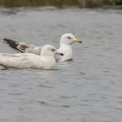
Iceland Gull, Lossie estuary 26 May 2016 (David Main)
25/5/2016 (19:15-20:15) Manx Shearwater 12, Fulmar 50, Gannet 183, Kittiwake 211, Great Skua 1, Red-throated Diver 2 past Lossiemouth in 1 hour Bob Proctor
25/5/2016 Wood Warbler 1 singing Whiteash Hill Wood (c.NJ369584) Martin & Jenny Cook
25/5/2016 (06:40) Little Egret 1 Lossie estuary (well upstream) Henry Farquhar
24/5/2016 crossbill sp. 17, Tree Pipit 2 Newtyle (NJ0552) Mike Crutch
24/5/2016 (20:05-21:05) Great Skua 1, Gannet 175, Fulmar 18, Kittiwake 268, Guillemot 47, Black Guillemot 1, Sandwich Tern 2, Common Tern 6 past Lossiemouth in 1 hour Bob Proctor
24/5/2016 Curlew Sandpiper 1, Ringed Plover 1134, Dunlin 115, Knot 97, Sanderling 45 Findhorn Bay Gordon McMullins
24/5/2016 (11:00) Little Egret 1 Lossie estuary (upstream, disturbed by dogs and flew west) David Main
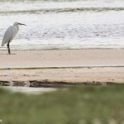
Little Egret, Lossie estuary 24 May 2016 (David Main)
23/5/2016 Whimbrel 1 Lossie estuary Bob Proctor
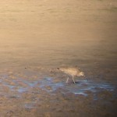
Whimbrel, Lossie estuary 23 May 2016 (Bob Proctor)
23/5/2016 (20:40) Little Egret 1 Lossie estuary (opposite car park) Henry Farquhar
see 17/5/2016 and 19/5/2016 King Eider records
23/5/2016 (19:00) Little Egret 1 Lossie estuary (flew in and headed away north) Bob Proctor
23/5/2016 Ringed Plover 1600+, Dunlin 400+, Knot 108, Sanderling c.25, Curlew Sandpiper 1, Cuckoo 1, Goosander 36, Mute Swan 89 Findhorn Bay Roy Dennis
23/5/2016 Teal 1 Mosset Burn (at Findhorn Bay) Roy Dennis
23/5/2016 (10:50) Little Egret 1 Lossie estuary Gordon Biggs
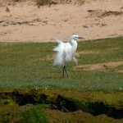 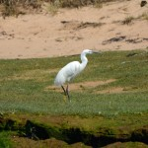
Little Egret on the Lossie estuary, 23 May 2016 (Gordon Biggs)
23/5/2016 Ringed Plover 1480, Dunlin c.300, Knot 89, Sanderling 41, Curlew Sandpiper 1, Bar-tailed Godwit 2 Findhorn Bay Gordon McMullins, Martin Cook
23/5/2016 Ringed Plover 47, Dunlin 63, Little Tern 1 Spey estuary Martin Cook
23/5/2016 Shelduck 10 flew west, Great Northern Diver 2 Spey Bay (off Tugnet) Martin Cook
22/5/2016 Red-throated Diver 1, Common Scoter 8 off Cullen Mike Crutch
22/5/2016 (16:15-17:15) Puffin 1, Guillemot 354, Razorbill 18, Gannet 83, Fulmar 13, Kittiwake 191, Common Scoter 6 past Lossiemouth in 1 hour Bob Proctor
22/5/2016 Great Northern Diver 3 Lossiemouth (on sea but distant) Bob Proctor
22/5/2016 Common Scoter c.20 (flew east), Swift 6 Burghead Bob Johnson
22/5/2016 Short-eared Owl 1 Findhorn Bay (off the bird hide) Gordon McMullins
22/5/2016 Curlew Sandpiper 1, Knot 57, Sanderling 31 Findhorn Bay Gordon McMullins
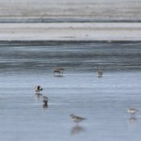 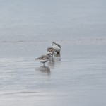
Curlew Sandpiper [left, at the back] and Sanderlings, Findhorn Bay 22 May 2016 (Gordon McMullins)
21/5/2016 Curlew Sandpiper 1, Knot 40 Findhorn Bay Richard Somers Cocks, Gordon McMullins
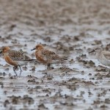 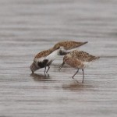
Knot [left] and Curlew Sandpiper with Dunlin, Findhorn Bay 21 May 2016 (Richard Somers Cocks)
21/5/2016 Curlew Sandpiper 1, Sanderling 22 Findhorn Bay Roy Dennis
21/5/2016 Short-eared Owl 1 Findhorn Bay per Birdguides
21/5/2016 (06:00-07:00) Puffin 13, Guillemot 1350, Razorbill 34, Black Guillemot 1, Kittiwake 201, Common Tern 3, Manx Shearwater 1, Great Northern Diver 2, Red-throated Diver 3, Common Scoter 40, Velvet Scoter 1 past Lossiemouth in 1 hour Bob Proctor
20/5/2016 Spotted Flycatcher pair Balnacoul (NJ316593) Alastair Young
20/5/2016 Ringed Plover 1946, Dunlin 325 Findhorn Bay Gordon McMullins
20/5/2016 Barn Owl 1 Pitgaveny crossroads Margaret Sharpe
20/5/2016 Kingfisher 1, Garden Warbler 1 River Spey near Fochabers Steve Murkin, Martin Cook
20/5/2016 Curlew Sandpiper 1, Knot 59, Sanderling 9 Findhorn Bay Richard Somers Cocks
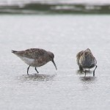
Curlew Sandpiper, Findhorn Bay 20 May 2016 (Richard Somers Cocks)
19/5/2016 King Eider 1 (male) flew east past Burghead Gordon Hamlett
19/5/2016 Ringed Plover 1502+, Dunlin 245, Sanderling 14, Knot 58, Turnstone 2, Whimbrel 1 Findhorn Bay Gordon McMullins
19/5/2016 Little Tern 3, Sanderling 3, Ringed Plover 6 Lossiemouth east beach Margaret Sharpe
19/5/2016 Woodcock 1, crossbill sp. 12+ Newtyle Forest (NJ0552) Mike Crutch
19/5/2016 Little Tern 17, Ringed Plover 82, Dunlin 46, Long-tailed Duck 1 (male), Goosander 29, Red-breasted Merganser 3, Goldeneye 4 Spey estuary Martin Cook
19/5/2016 Short-eared Owl 1 (in south-east corner), Ringed Plover 1280, Dunlin 320, Knot 14 Findhorn Bay Richard Somers Cocks
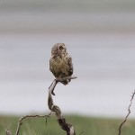
Short-eared Owl, Findhorn Bay 19 May 2016 (Richard Somers Cocks)
19/5/2016 Goosander 14, Teal 2, Sand Martin c.60, Pink-footed Goose 10 (in field nearby) Mosset Burn at Findhorn Bay Richard Somers Cocks
18/5/2016 Swift 2 Loch Spynie Roy Dennis
18/5/2016 Knot 2, Sanderling 3 Lossie estuary Roy Dennis
18/5/2016 (17:35-18:35) Manx Shearwater 16, Gannet 219, Fulmar 43, Guillemot 688, Kittiwake 171, Red-throated Diver 1 past Lossiemouth in 1 hour Bob Proctor
18/5/2016 Swift 2 Kinloss Allan Lawrence
18/5/2016 Ringed Plover 1143, Dunlin 247, Sanderling 2, Turnstone 3, Knot 21, Whimbrel 1 Findhorn Bay (NJ0462) Gordon McMullins
18/5/2016 Barnacle Goose 1, Pink-footed Goose 19 Findhorn Bay (south end) and Netherton fields Gordon McMullins
18/5/2016 Mandarin Duck 1 (male) Logie (River Findhorn NJ0050) Mike Crutch
17/5/2016 King Eider 1 (male) flew west past Burghead Gordon Hamlett
17/5/2016 Bar-tailed Godwit 3, Goosander 13, Sparrowhawk 1 Lossie estuary Henry Farquhar
17/5/2016 Ringed Plover 750, Dunlin 160, Sanderling 4, Turnstone 2 Findhorn Bay Roy Dennis
16/5/2016 Spotted Flycatcher 1, Grey Wagtail 5 (pair with 3 juveniles) Gallowhill (NJ4853) Valerie Sheach Leith
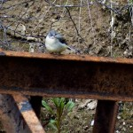
Juvenile Grey Wagtail, Gallowhill 16 May 2016 (Valerie Sheach Leith)
16/5/2016 Short-eared Owl 1, Pink-footed Goose 17 Findhorn Bay (Netherton area) Roy Dennis
16/5/2016 Little Egret 1, Goosander 17, Red-breasted Merganser 4, Tufted Duck 1, Whimbrel 2, Black-tailed Godwit 1, Bar-tailed Godwit 1 Findhorn Bay (south-west corner) Roy Dennis
16/5/2016 Spotted Sandpiper 1, Redshank 5, Teal 1 Mosset Burn Roy Dennis
16/5/2016 Spotted Sandpiper 1 Mosset Burn at Findhorn Bay (NJ044610) Richard Somers Cocks, Gordon McMullins, Martin Cook, Bob Proctor
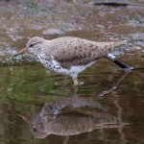 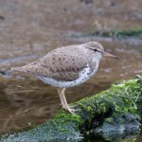 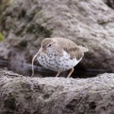 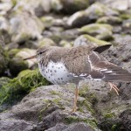
Spotted Sandpiper in the Mosset Burn, 16 May 2016 (Richard Somers Cocks)
16/5/2016 Ringed Plover 1291, Dunlin 235, Sanderling 5, Turnstone 2 Findhorn Bay (off east side) Gordon McMullins, Richard Somers Cocks
16/5/2016 Little Egret 1, Greenshank 1, Whimbrel 1, Wigeon 9 Findhorn Bay (south-west corner) Gordon McMullins, Martin Cook
16/5/2016 Spotted Flycatcher 1 Elgin (River Lossie near Sports Centre) Margaret Sharpe
16/5/2016 Whitethroat 5 singing along old railway line between Masonhaugh Quarry and Cummingston Bob Johnson
16/5/2016 Sedge Warbler 1 Masonhaugh Quarry (NJ127691) Bob Johnson
15/5/2016 Little Egret 1 Findhorn Bay (south-west corner) Richard Somers Cocks
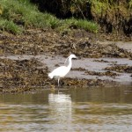
Little Egret, Findhorn Bay 15 May 2016 (Richard Somers Cocks)
15/5/2016 Whimbrel 2 Findhorn Bay (south end) Gordon McMullins
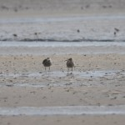
Whimbrel in Findhorn Bay, 15 May 2016 Gordon McMullins
14/5/2016 Redstart 1 Bridge of Tommore (NJ193352) David Main, Duncan Gibson, Henry Farquhar, Jimmy Mair
14/5/2016 Stock Dove 1 Cloddach wetland David Main, Duncan Gibson, Henry Farquhar, Jimmy Mair
14/5/2016 Little Tern 1 Spey estuary David Main, Duncan Gibson, Henry Farquhar, Jimmy Mair
14/5/2016 Knot 1, Wheatear 1 Spey estuary Margaret & Chris Sharpe, Alastair Young, David Law
14/5/2016 Whimbrel 1 Findhorn Bay Margaret & Chris Sharpe, Alastair Young, David Law
14/5/2016 Garden Warbler 1 Speyside Way south of Bogmoor (NJ348612) Margaret & Chris Sharpe, Alastair Young, David Law
14/5/2016 Grasshopper Warbler 1 Raefin (NJ403571) Margaret & Chris Sharpe, Alastair Young, David Law
14/5/2016 Stock Dove 1 Darkland Margaret & Chris Sharpe, Alastair Young, David Law
14/5/2016 Sanderling 1, Little Tern 1, Arctic Skua 1, Wheatear 1 Spey estuary
14/5/2016 Knot 2 Findhorn Bay (south end) Allan Lawrence, Alan Edward, Ian Bailey
14/5/2016 Kingfisher 1 River Spey under A96 bridge Steve Murkin, Mike Collins
14/5/2016 Black-throated Diver 3, Red-throated Diver 1 Spey Bay (off Tugnet) Mike Collins, Sue Pianta-Scott, Steve & Isy Murkin
14/5/2016 Little Tern 2 Spey estuary Bob Johnson, Martin & Jenny Cook, Sheena Nicolson
14/5/2016 Turnstone 2 Burghead Bob Johnson, Martin & Jenny Cook, Sheena Nicolson
14/5/2016 Garden Warbler 2 River Spey near Mosstodloch (NJ345606) Bob Johnson, Martin & Jenny Cook, Sheena Nicolson
14/5/2016 Cuckoo 1 Wellheads (NJ3860) Steve Murkin
14/5/2016 Gadwall 2 (a pair) Findhorn Bay (Mosset Burn) Allan Lawrence, Alan Edward, Ian Bailey, Alison Ritchie
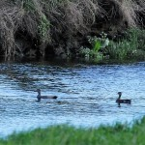
Gadwall on the Mosset Burn 14 May 2016 (Allan Lawrence)
14/5/2016 Little Egret 1 Findhorn Bay (old Findhorn channel in south-west corner) Gordon McMullins
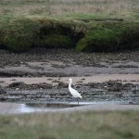
Little Egret, Findhorn Bay 14 May 2016 (Gordon McMullins)
13/5/2016 Goosander 40 Findhorn Bay (south-west corner) Geoff & Debbie Smith
12/5/2016 Scaup 1 (male) Easter Bauds (Mosstodloch) Alastair Young
12/5/2016 Slavonian Grebe 1 Findhorn Bay Richard Somers Cocks
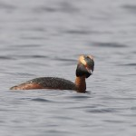
Slavonian Grebe, Findhorn Bay 12 May 2016 (Richard Somers Cocks)
12/5/2016 Cuckoo 4, Spotted Flycatcher 1 Johnstripe (NJ0447) Mike Crutch
12/5/2016 Ptarmigan 3, Snow Bunting 2 Stob Coire an t-Sneachda (Cairngorms) Martin, Jenny & Alistair Cook
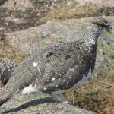 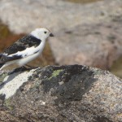
Ptarmigan and Snow Bunting, Cairngorms 15 May 2016 (Jenny Cook)
12/5/2016 (11:30) White-billed Diver 1 Burghead per Birdguides
11/5/2016 Garden Warbler 2 River Spey near Mosstodloch Martin Cook
11/5/2016 Gadwall 2 (a pair) Findhorn Bay (Mosset Burn mouth) Allan Lawrence
11/5/2016 Cuckoo 1 Meikleburn Farm (NH911470) Jack Harrison
10/5/2016 Cuckoo 2 Altyre (NJ0253) Mike Crutch
10/5/2016 Spotted Flycatcher 1 Half Davoch Roy Dennis
10/5/2016 Cuckoo 1 Balnught (NH892403) Jack Harrison
10/5/2016 Grey Partridge 2 Williamston (Hopeman NJ162693) Bob Johnson
10/5/2016 Grey Partridge 2 Lower Mains (Findrassie NJ194657) Bob Johnson
10/5/109/5/2016 Gadwall 1 (male) Balormie (NJ2168) Bob Proctor
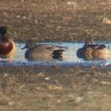
Gadwall [centre], Balormie 9 May 2016 (Bob Proctor)
9/5/2016 Little Egret 1 (south end near rifle range), Whimbrel 3 (near bird hide) Findhorn Bay Roy Dennis
9/5/2016 Little Egret 1, Whimbrel 1 Findhorn Bay (near Netherton) Gordon McMullins
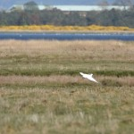
Little Egret in Findhorn Bay, 9 May 2016 (Gordon McMullins)
9/5/2016 Spotted Flycatcher 1 Archiestown Alastair Young
9/5/2016 Short-eared Owl 1 Kinloss airfield (north side) Allan Lawrence
9/5/2016 Ringed Plover c.20, Black Guillemot 1 Burghead Bob Johnson
9/5/2016 Grey Partridge 1 between Hopeman-Cummingston (NJ143692) Bob Johnson
8/5/2016 Garden Warbler 1 River Spey near Mosstodloch Alastair Young
8/5/2016 Stonechat 1, Whitethroat 1, Rock Pipit 1 Hopeman Robert Potter
8/5/2016 Short-eared Owl 1 Chapelton wetland (Forres) John & Belinda Shackleton
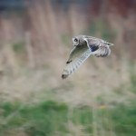
Short-eared Owl, Chapelton wetland 8 May 2016 (John & Belinda Shackleton)
8/5/2016 Red-breasted Merganser 3 pairs Forres (River Findhorn below A96 bridge) Ian Bailey
8/5/2016 (17:00) Whimbrel 11 Spey estuary Duncan Gibson, Martin Cook
8/5/2016 (10:15) Garganey 1 (male) Spey estuary Martin Cook, Aberdeen SOC
8/5/2016 Whimbrel 2 Findhorn Bay Duncan Gibson
8/5/2016 Gadwall 2 (a pair) Findhorn Bay (south side) Allan Lawrence
8/5/2016 Lesser Redpoll 2 on Niger feeder Moor of Tore (NJ0954) Geoff & Debbie Smith
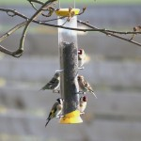
Lesser Redpoll [middle right] with Siskin and Goldfinches, Moor of Tore 8 May 2016 (Geoff Smith)
7/5/2016 (19:00-20:00) Manx Shearwater 1, Gannet 186, Kittiwake 111, Razorbill 109, Guillemot 40, Great Northern Diver 1, Red-throated Diver 1 past Lossiemouth in 1 hour Bob Proctor
7/5/2016 Crane 2 reported in a field near Garmouth viaduct per Scottish Dolphin Centre (Tugnet)
7/5/2016 Gadwall 1 (male) Lossie Forest (NJ2867) Martin & Jenny Cook
7/5/2016 Ringed Plover 449, Dunlin 796 Findhorn Bay Gordon McMullins
7/5/2016 Wheatear 2, Grasshopper Warbler 1, Blackcap 2, Chiffchaff 3, Sedge Warbler 7 Loch Spynie Margaret Sharpe
7/5/2016 Common Tern 2 Loch Spynie Lisa Stewart
7/5/2016 Tree Pipit 1 Whiteash Wood (NJ371595) David Law
6/5/2016 Gadwall 1 (male), Shelduck 3, Golden Plover 2, White Wagtail 4 Balormie (NJ2168) Bob Proctor
6/5/2016 Great Northern Diver 4, Red-throated Diver 1, Common Scoter 20 Spey Bay (off Tugnet) Martin Cook
6/5/2016 Little Tern 5, Arctic Tern c.20, Sandwich Tern 4 Spey estuary Martin Cook
6/5/2016 Swift c.20, Sedge Warbler 1 Balvenie (Dufftown) Dave Wheeler
6/5/2016 Little Tern 4 Spey estuary Eddie Seal
6/5/2016 White Wagtail 1 Burghead maltings Bob Johnson
6/5/2016 Whitethroat 1 Masonhaugh Quarry nr. Burghead (NJ127691) Bob Johnson
6/5/2016 House Martin pairs at Burghead and Cummingston Bob Johnson
6/5/2016 House Martin 4 Clochan Martin Cook
5/5/2016 Grasshopper Warbler 1 singing Findhorn Bay (south end NJ050610) Robert Potter
5/5/2016 Swift over Lossiemouth Duncan Gibson
5/5/2016 Swift 4 Bishopmill (Elgin) Bob Proctor
5/5/2016 Gadwall 1 (male), Golden Plover 1, Ringed Plover 1, White Wagtail 4 Balormie pig farm (NJ2168) Bob Proctor
5/5/2016 Swift 2 Garmouth Eddie Seal
5/5/2016 Greylag Goose 24 Whitefold (NH893448) Jack Harrison
5/5/2016 Cuckoo 1 near Levrattich (NH948460) Jack Harrison
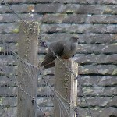
Cuckoo near Levrattich, 5 May 2016 (Jack Harrison)
5/5/2016 White Wagtail 1 Wester Delnies shore (NH8556) Beryl Blackhall
5/5/2016 (10:00) Hoopoe 1 Tugnet (on wires beside Dolphin Centre NJ350653) but flew away west across the river Harris Brooker, Martin Cook et al.
5/5/2016 Little Ringed Plover 1, Whitethroat 1, Sedge Warbler 1, House Martin 1, Arctic Tern 10+, Red-breasted Merganser 10, Goosander 4, Goldeneye 7 Spey estuary Martin Cook
4/5/2016 Whimbrel 1 (near Mosset Burn mouth), Black-tailed Godwit 8, Pintail 8 (south-west corner) Findhorn Bay Richard Somers Cocks
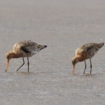 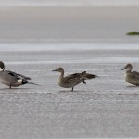
Black-tailed Godwits and Pintail, Findhorn Bay 4 May 2016 (Richard Somers Cocks)
4/5/2016 Whimbrel 1 Burghead Alison Ritchie
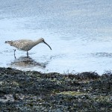 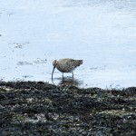
Whimbrel, Burghead 4 May 2016 (Alison Ritchie)
4/5/2016 Wheatear 2 Lossie estuary David Main
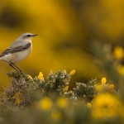 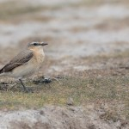
Wheatears at the Lossie estuary, 4 May 2016 (David Main)
4/5/2016 Gadwall 1 (male), Wigeon 1, Shelduck 5, White Wagtail 1 Balormie pig farm (NJ2168) Bob Proctor
4/5/2016 crossbill sp. 2 Clovenside Cemetery (Forres) Bob Proctor
4/5/2016 Goosander 3, Greylag Goose 4, Shelduck 3, Common Sandpiper 2 Lossie estuary Henry Farquhar
3/5/2016 Sandwich Tern 152, Common Tern 40 Findhorn beach Richard Somers Cocks
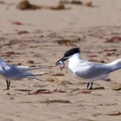 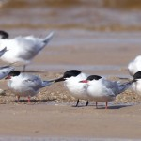
Sandwich and Common Terns, Findhorn 3 May 2016 (Richard Somers Cocks)
3/5/2016 Whimbrel 1 Findhorn Bay (south end) Richard Somers Cocks, Gordon McMullins
3/5/2016 White Wagtail 1 Nairn harbour Beryl Blackhall
3/5/2016 Whitethroat 1, White Wagtail 1 Lossie estuary David Main
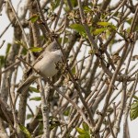 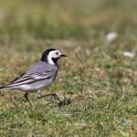
Whitethroat and White Wagtail, Lossie estuary 3 May 2016 (David Main)
2/5/2016 Pink-footed Goose 2030, Pintail 28, Ringed Plover 10, Grey Heron 14 Findhorn Bay (south end) Gordon McMullins, Richard Somers Cocks
2/5/2016 Golden Plover c.160 Netherton (Findhorn Bay, in a field) Gordon McMullins
2/5/2016 Sand Martin c.100 Nairn (river just downstream from A96 bridge) Jack Harrison
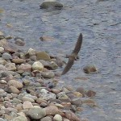
Sand Martin at Nairn, 2 May 2016 (Jack Harrison)
2/5/2016 Wheatear 1, Ringed Plover 12, Dunlin 6 Burghead (north shore) Bob Johnson
2/5/2016 Stonechat 1 (male) Tomnamoon (NJ0449) Mike Crutch
2/5/2016 Stonechat 2 (a pair), Wheatear 1 Hopeman Mike Crutch
2/5/2016 Iceland Gull 1 (2nd winter) Lossie estuary Richard Somers Cocks, Bob Proctor
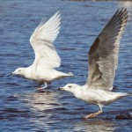 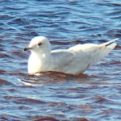
Iceland Gull, Lossie estuary 2 May 2016 (Richard Somers Cocks [left], Bob Proctor)
2/5/2016 (07:00-08:00) Arctic Tern 1, Common Tern 1, Gannet 199, Razorbill 14, Guillemot 13, Common Scoter 48, Long-tailed Duck 6, Kittiwake 85, Red-throated Diver 5 past Lossiemouth in 1 hour Bob Proctor
1/5/2016 Great Northern Diver 4, Black-throated Diver 2, Red-throated Diver 4, Eider 48, Guillemot 230, Razorbill 33, Black Guillemot 6 between Buckie harbour and Logie Head Moray Bird Club (from Gemini Explorer)
1/5/2016 Long-tailed Duck 1 Buckie harbour Moray Bird Club
1/5/2016 Short-eared Owl 1 Bloomfield (Findochty NJ4767) Lenny Simpson
1/5/2016 Wheatear 8 Netherton (in ploughed field just south of the farm NJ0361) Richard Somers Cocks
1/5/2016 Black-tailed Godwit 9 Findhorn Bay (south end) Richard Somers Cocks
1/5/2016 (12:45-13:15) Gannet 127, Sandwich Tern 9, Common Scoter 11 past Lossiemouth in 30 minutes Bob Proctor
1/5/2016 (09:00-09:30) Kittiwake 59, Gannet 52, Red-throated Diver 3 past Lossiemouth in 30 minutes Bob Proctor
1/5/2016 Cuckoo 1 Tomnamoon (NJ0449) Mike Crutch
1/5/2016 (14:30) White-billed Diver 1, Great Northern Diver 5, Red-throated Diver 4, Guillemot 35, Razorbill 20, Great Skua 1 off Lossiemouth harbour Bob Proctor
1/5/2016 (mid day) White-billed Diver 1 (adult) off Lossiemouth harbour Bob Proctor
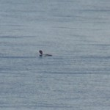
White-billed Diver off Lossiemouth, 1 May 2016 (Bob Proctor)

