31/3/2017 Osprey 1 South of Forres Mike Crutch
31/3/2017 Mediterranean Gull 1 Lossie Estuary David Main
31/3/2017 Waxwing 34 Elgin(west end) David Main
31/3/2017 Chiffchaff 3 Nairn (between Kingsteps and sewage works) Beryl Blackhall
31/3/2017 Black-tailed Godwit 1, Sandwich Tern 11, Sanderling 14, Brent Goose c80 Nairn (east beach) Beryl Blackhall
31/3/2017 Waxwing 18 Burghead (beside school) per Birdguides
31/3/2017 (13:00) White-billed Diver 1 Burghead (offshore, but distant) per Birdguides
31/3/2017 crossbill sp. 2 Banchor (NH911407) Alison Ritchie
31/3/2017 Greenshank 1 Findhorn Bay (on the flooded carse NJ047612) Gordon McMullins
30/3/2017 Woodcock 1 (roding) Lhanbryde (Crooked Wood) David Law
30/3/2017 Curlew 100 Garmouth Stuart Massie
30/3/2017 Little Egret 1 Findhorn Bay (south side, east of target) Allan Lawrence
30/3/2017 Waxwing 6 Forres (Grantown Road) Karen Guthrie
30/3/2017 Waxwing 36 Elgin (west end) David Main
30/3/2017 Sandwich Tern 1 Burghead David & Carol Shaw
30/3/2017 Brambling 1 (male) Forres (garden feeder) Alison Ritchie
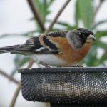
Brambling, Forres 30 March 2017 (Alison Ritchie)
30/3/2017 (16:22) White-billed Diver 1 Cullen (offshore from Seaview Place) per Birdguides
30/3/2017 (13:05) White-billed Diver 2 Burghead (from end of Bath Street, but distant) per Birdguides
30/3/2017 (08:15) Snipe 1 (drumming), Curlew 2 (a pair) Tomnamoon (NJ0449) Mike Crutch
29/3/2017 Little Egret 1 Findhorn Bay (south side) Allan Lawrence
29/3/2017 Common Scoter 10, Red-throated Diver 6, Long-tailed Duck 300+, Gannet 100+, Knot 1, Turnstone 34 Burghead Alan Macaskill
29/3/2017 Sandwich Tern 1, Chiffchaff 1 Findhorn Alan Macaskill
29/3/2017 Sandwich Tern 1, Gannet c150, Razorbill 200+, Kittiwake 150+, Guillemot c50 Nairn (off harbour) Alan Macaskill
29/3/2017 Waxwing 25 Elgin (west end) David Main
29/3/2017 Wheatear 1 Burghead (Burghead Thistle football ground) David Main
28/3/2017 Waxwing 27 Elgin (west end) David Main
27/3/2017 Chiffchaff 1 Kinloss Mike Crutch
27/3/2017 Chiffchaff 1 Mundole/A940 Mike Crutch
27/3/2017 Kingfisher 1 Elgin (River Lossie) Margaret Sharpe
27/3/2017 Waxwing 27, Blackcap 1 (female) Elgin (west end) Eileen Main
27/3/2017 Pink-footed Goose c2350, Barnacle Goose 1 Findhorn Bay (south side) Richard Somers Cocks
27/3/2017 Snow Goose (blue morph) 2 Findhorn Bay (south side) (last seen at 15:30 heading west towards the Culbin) Richard Somers Cocks
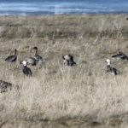
Snow Geese at Findhorn Bay, 27 March 2017 (Richard Somers Cocks)
27/3/2017 (13:45) Snow Goose (blue morph) 2, Barnacle Goose 1, Red-breasted Merganser 14 Findhorn Bay (south side) Mike Crutch & Roy Dennis
27/3/2017 (11:54) White-billed Diver 1 Burghead (1.6 km east, c.800 m offshore) per Birdguides
27/3/2017 (12:00) Snow Goose (blue morph) 2 Findhorn Bay (south side near Mosset Burn mouth) Allan Lawrence
27/3/2017 Black-throated Diver 13 Burghead Bay (off Findhorn dunes) Gordon McMullins
27/3/2017 Whooper Swan 16 Scarffbanks Lisa Stewart
26/3/2017 Waxwing 13, Blackcap 1 (female) Elgin (west end) Eileen Main
26/3/2017 Waxwing 4, Chiffchaff 1 Inchberry Alastair Young
26/3/2017 Mealy Redpoll 4, Chiffchaff 3 Teindland Alastair Young
26/3/2017 egret sp. (probably Little) 1 Lachlanwells (Alves NJ1360) Ian Green
26/3/2017 Osprey 1 Findhorn Bay Richard Somers Cocks
26/3/2017 Black-throated Diver 1, Red-throated Diver 6, Common Scoter 540, Eider 66, Goldeneye 27, Long-tailed Duck 20, Red-breasted Merganser 3 Spey Bay (off mouth of River Spey) Martin Cook
25/3/2017 Waxwing 6, Blackcap 1 (female) Elgin (west end) Eileen Main
25/3/2017 Chiffchaff 1 Teindland Alastair Young
25/3/2017 Sand Martin 2, Fieldfare 14 River Spey at Warren Wood Alastair Young
25/3/2017 Little Egret 1 Gilston (NJ205659) Eric Jensen
25/3/2017 Glaucous Gull 1 (juvenile), Chiffchaff 4, Curlew 133 Loch Spynie Moray Bird Club
25/3/2017 Purple Sandpiper 29, Turnstone 100+ Lossiemouth (off north pier) Gordon Biggs
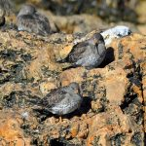
Purple Sandpipers at Lossiemouth, 25 March 2017 (Gordon Biggs)
25/3/2017 (06:40-07:40) Razorbill 1522, Gannet 179, Kittiwake 455, Long-tailed Duck 263, Common Scoter 15, Red-throated Diver 2 past Lossiemouth in 1 hour Bob Proctor
24/3/2017 Chiffchaff 1 Elgin (beside River Lossie below Elgin Academy) Eric Jensen
24/3/2017 (18:30) Little Egret 1 flew east over Dallachy airfield (Bogmoor NJ3663) Alastair Millar
24/3/2017 Brent Goose 69, Purple Sandpiper 9 Nairn west beach John Scrimgeour
24/3/2017 Whooper Swan 25 Culbin Bar (flew over) John Scrimgeour
24/3/2017 Little Egret 1 Kingsteps (Nairn) John Scrimgeour
24/3/2017 Scaup 1, Pintail 2, Goldeneye 4 Loch Loy John Scrimgeour
24/3/2017 Black-throated Diver 1 off Portknockie Martin Cook
24/3/2017 Red-throated Diver 4, Razorbill c.120 Cullen (off caravan park) Martin Cook
24/3/2017 Waxwing 38 Elgin (west end) David Main
24/3/2017 Wheatear 1 Kinloss barracks Allan Lawrence
24/3/2017 Pintail 127, Shelduck 33, Pink-footed Goose 280, Redshank 731, Oystercatcher 191, Curlew 79 Findhorn Bay (from Netherton) Mike Crutch
23/3/2017 crossbill sp. 2 Kinloss Allan Lawrence
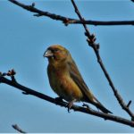
Crossbill, Kinloss 23 March 2017 (Allan Lawrence)
23/3/2017 Bar-tailed Godwit 26 Nairn east beach
23/3/2017 Brent Goose 72 (68 in front of golf club, 4 at river mouth) Nairn John Scrimgeour
23/3/2017 Purple Sandpiper 9 Nairn west beach John Scrimgeour
23/3/2017 Brambling 1 Tradespark (Nairn) John Scrimgeour
23/3/2017 Chiffchaff 1 Inchberry Alastair Young
23/3/2017 White-billed Diver 1 Cullen (off caravan park) Dave Pullan
23/3/2017 Waxwing 15 Elgin (west end) David Main
23/3/2017 Iceland Gull 2 Lossie estuary David Main
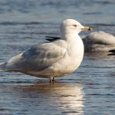
Iceland Gull (3rd winter), Lossie estuary 23 March 2017 (David Main)
23/3/2017 Sand Martin 2, Goldeneye 10, Chiffchaff 2 Fochabers (River Spey near Quarry Pool) Martin Cook
23/3/2017 Whooper Swan 44, Greylag Goose 490, Wigeon 37, Chiffchaff 2 Loch Spynie Martin Cook
23/3/2017 Velvet Scoter 12, Common Scoter 100+, Long-tailed Duck 280 Spey Bay (Boar's Head Rock area) Martin Cook
23/3/2017 Chiffchaff 2 Lossie Forest Martin Cook
23/3/2017 Goldeneye 21, Black-headed Gull 220, Chiffchaff 1 Loch na Bo Martin Cook
23/3/2017 Lesser Black-backed Gull 7 Lhanbryde pig farm Martin Cook
23/3/2017 Whooper Swan 1, Goldeneye 5, Lesser Black-backed Gull 4 Loch Oire Martin Cook
22/3/2017 Siskin 50+ Tradespark (Nairn) Chris James
22/3/2017 Crested Tit 2 Glenferness (NH953423) Martin Cook
22/3/2017 Whooper Swan 42 Scarffbanks (NJ2466) Martin Cook
22/3/2017 Chiffchaff 1 Loch Spynie Martin Cook
22/3/2017 Waxwing 14 Forres (Waterford) Ian Bailey
22/3/2017 Waxwing 18 New Elgin (Robertson Road) David Law
22/3/2017 Waxwing 37 Elgin (WG Catto Funeral Home) Bob Proctor
21/3/2017 Waxwing 36 Elgin (west end) David Main
21/3/2017 Sandwich Tern 2 Burghead Bay Allan Lawrence
21/3/2017 Lesser Redpoll 10 Forres (on garden feeders) Alison Ritchie
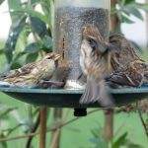
Lesser Redpolls, Forres 21 March 2017 (Alison Ritchie)
21/3/2017 Pink-footed Goose c.280 Little Aitnoch Alison Ritchie
21/3/2017 Red Kite 1 Dunearn Alison Ritchie
21/3/2017 Goldeneye 3, Teal 6, crossbill sp. 2 Loch Belivet Alison Ritchie
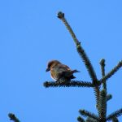
Crossbill, Loch Belivat 21 March 2017 (Alison Ritchie)
21/3/2017 Fieldfare c.80 Glenshiel (NH969536) Alison Ritchie
21/3/2017 crossbill sp. 13 Tilliglens (NJ0046) Mike Crutch
20/3/2017 Waxwing 32 Elgin (west end) David Main
20/3/2017 Iceland Gull 1 Lossie estuary Melvin Morrison
20/3/2017 Grey Wagtail 2 Elgin (Linkwood Burn) Stuart Massie
20/3/2017 Chiffchaff 2 Tradespark Wood (Nairn) Simon Foster
19/3/2017 Waxwing 13 Burghead David Main
19/3/2017 Waxwing 28 Elgin (west end) David Main
19/3/2017 Oystercatcher 336 Culbin Bar Roy Dennis
19/3/2017 Chiffchaff 1 Cloddach quarry (main entrance) Duncan Gibson
19/3/2017 Chiffchaff 1 Spey Bay riverside woodland (NJ3464) Mike Collins
19/3/2017 Lesser Black-backed Gull 6 (1 on Halfords roof, 5 Moycroft), Great Black-backed Gull 2 (Moycroft) Elgin Bob Proctor
19/3/2017 (07:15-08:15) Long-tailed Duck 698, Common Scoter 3, Gannet 136, Fulmar 4, Kittiwake 435, Razorbill 16, Black Guillemot 4, Red-throated Diver 1 past Lossiemouth in 1 hour Bob Proctor
18/3/2017 Brent Goose 25 Nairn harbour Roy Dennis
18/3/2017 Iceland Gull 1 (2nd winter) Lossie estuary Henry Farquhar
18/3/2017 Whooper Swan 48 Gordonsward/Bailliesland area (c.NJ2565) Lisa Stewart
18/3/2017 Waxwing 7 Elgin (west end) David Main
18/3/2017 Goosander 2, Whooper Swan 1 Loch na Bo Martin & Jenny Cook
18/3/2017 Goldeneye 25 Spey estuary Martin Cook
18/3/2017 Siskin 11 Lossiemouth (on garden feeder) Margaret Sharpe
18/3/2017 Red-throated Diver 1 off Lossiemouth north pier Gordon Biggs
18/3/2017 Hooded Crow 1 Lower Rafford Gordon Biggs
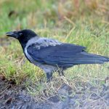
Hooded Crow, Lower Rafford 18 March 2017 (Gordon Biggs)
18/3/2017 Eider 150+ (300m west of harbour), Turnstone 27 (on harbour wall) Burghead Tony Backx
18/3/2017 Greylag Goose 38 Auchnacloich (NH9056) Mike Crutch
17/3/2017 Waxwing 13 Hopeman Eddie Pratt
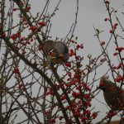 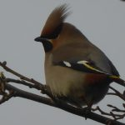
Waxwings, Hopeman 17 March 2017 (Eddie Pratt)
17/3/2017 Chiffchaff 1 Loch Spynie (near hide) Dave Pullan
17/3/2017 Brent Goose 24 Nairn Jack Harrison
17/3/2017 Waxwing 32 Elgin (west end) David Main
17/3/2017 Meadow Pipits back on breeding territories Altyre (NJ0253) Mike Crutch
17/3/2017 Brambling 1 with Chaffinches Moyness Alison Ritchie
17/3/2017 Lesser Redpoll 2 on garden feeder Knockomie (Forres) Karen Guthrie
17/3/2017 (09:30) Waxwing 30 Elgin (Lossiemouth road) Bob Proctor
16/3/2017 Waxwing 52 Elgin (west end) David Main
16/3/2017 Chaffinch 300+ Moyness Jack Harrison
16/3/2017 Tufted Duck 12 Elgin (Cooper Park pond) Jack Harrison
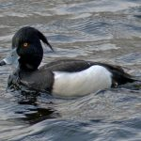
Tufted Duck, Elgin 16 March 2017 (Jack Harrison)
15/3/2017 Waxwing 38, Blackcap 1 Elgin (west end) David Main
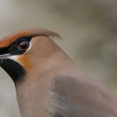
Waxwing, Elgin 15 March 2017 (David Main)
15/3/2017 Greylag Goose 2 pairs near Dunearn Lodge Jack Harrison
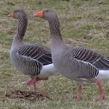
Greylag Geese, Dunearn 15 March 2017 (Jack Harrison)
15/3/2017 Gannet 74, Razorbill 85 flew west in 10 mins Burghead Bay (from Findhorn dunes) Richard Somers Cocks
15/3/2017 Fieldfare 23 Refouble (NH9540) Mike Crutch
15/3/2017 Fieldfare 89, Redwing 2 Tomnamoon (NJ0449) Mike Crutch
15/3/2017 Jack Snipe 1 (at NJ030618), Peregrine 1 Findhorn Bay (Netherton area) Mike Crutch
14/3/2017 Goosander 2 (a pair) Forres (on Mosset Burn in town) Ian Bailey
14/3/2017 Waxwing 8 Forres (town centre) Ian Bailey
14/3/2017 Waxwing 22 Elgin (west end) David Main
14/3/2017 Sandwich Tern 1 (flew west) Burghead Roy Dennis
14/3/2017 Waxwing 22 Elgin (east end) Roy Dennis
14/3/2017 Fieldfare 31, Redwing 2 Tomnamoon (NJ0449) Mike Crutch
14/3/2017 Black-throated Diver 1, Red-throated Diver 1, Long-tailed Duck 19, Razorbill 142 (flew past in 10 mins) Burghead Mike Crutch
14/3/2017 Iceland Gull 1 (juvenile) Lossie estuary Mike Crutch
13/3/2017 Waxwing 25, Blackcap 2 Elgin (west end) David Main
13/3/2017 Whooper Swan 17 Findhorn Bay Gordon McMullins
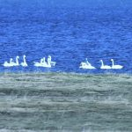
Whooper Swans in Findhorn Bay, 13 March 2017 (Gordon McMullins)
13/3/2017 Waxwing 4 Nairn (junction of Tradespark/Muircroft/Blairfield Roads NH869557) Jack Harrison
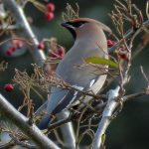
Waxwing, Nairn 13 March 2017 (Jack Harrison)
13/3/2017 Whooper Swan 16, Oystercatcher 257, Curlew 71, Shelduck 34, Pink-footed Goose 720+ Findhorn Bay (from Netherton) Mike Crutch
13/3/2017 Razorbill 184 flew west in 5 minutes, Common Scoter 29, Long-tailed Duck 17 Burghead Bay (from Findhorn dunes) Mike Crutch
13/3/2017 Ringed Plover 2 pairs, Magpie 12 Findhorn dunes Mike Crutch
12/3/2017 Waxwing 15 Mosstodloch (at A96 roundabout at Baxters entrance) Martin & Jenny Cook
12/3/2017 Shelduck 4, Curlew 40, Oystercatcher 27, Pink-footed Goose 950, Greylag Goose 23, Goosander 1, Wigeon 760, Stock Dove 4 Cloddach quarry Martin & Jenny Cook
12/3/2017 Teal 4 Aitnoch (Dava) Alison Ritchie
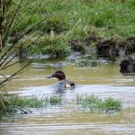
Teal at Aitnoch, 12 March 2017 (Alison Ritchie)
12/3/2017 Golden Plover 1, Teal 2 (a pair) Dunearn Alison Ritchie
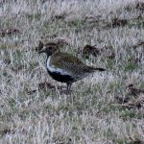
Golden Plover at Dunearn 12 March 2017 (Alison Ritchie)
12/3/2017 Pink-footed Goose 2400 Moyness-Craighead Alison Ritchie
12/3/2017 Redwing 70 Darkland David Law
12/3/2017 Iceland Gull 1 (adult) Lossie estuary Bob Proctor
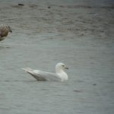
Iceland Gull, Lossie estuary 12 March 2017 (Bob Proctor)
12/3/2017 Grey Wagtail 1 Gallowhill Valerie Sheach Leith
12/3/2017 Waxwing 4 Elgin (west end) David Main
12/3/2017 Hooded Crow 2 Nairn east beach Lisa Stewart
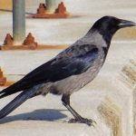
Hooded Crow at Nairn, 12 March 2017 (Lisa Stewart)
12/3/2017 crossbill sp. 8 Culbin Forest Lisa Stewart
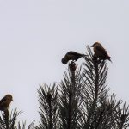
Crossbills in Culbin Forest, 12 March 2017 (Lisa Stewart)
12/3/2017 Great Northern Diver 1 Lossiemouth (on sea off the harbour) Bob Proctor
12/3/2017 (08:30-09:30) Long-tailed Duck 317, Red-throated Diver 2, Black Guillemot 4, Razorbill 10, Guillemot 2, Gannet 21, Fulmar 9, Kittiwake 26 past Lossiemouth in 1 hour Bob Proctor
12/3/2017 Goldeneye 31, Black-throated Diver 2, Red-throated Diver 13 Spey estuary and offshore Martin Cook
12/3/2017 Goldeneye 21, Teal 31 Dallachy landfill pool (NJ370640) Martin Cook
11/3/2017 Brent Goose c.80 Nairn shore Jill Sowden
11/3/2017 Waxwing 2 Elgin (west end) David Main
11/3/2017 Waxwing c.20 Forres (Grantown Road near Ferryhill) Karen Guthrie
11/3/2017 Waxwing 7 Nairn (Blairfield Road at Tradespark Wood end NH8655) Beryl Blackhall
11/3/2017 Scaup 1 (male), Woodcock 1, Water Rail 1 (heard) Loch Spynie Pete Gordon
11/3/2017 Yellow-legged Gull 1 probable (adult), Lesser Black-backed Gull 2 (adults) Lossie estuary Pete Gordon
11/3/2017 Common Scoter 200, Stonechat 2 Burghead Pete Gordon
11/3/2017 Scaup 1 (male), Stock Dove 1, Redwing 25, Fieldfare 70, Curlew 70, Linnet c.100 Loch Spynie and surrounds David Law
11/3/2017 Whooper Swan 45 Gordonsward (NJ2564) David Law
11/3/2017 Black-tailed Godwit 3 Findhorn Bay (off Minton) Gordon McMullins
11/3/2017 Great Northern Diver 3 Burghead Bay (off Findhorn dunes) Gordon McMullins
11/3/2017 Kingfisher 1 Delnapot-Blacksboat Neil Sutherland & Carol Armour
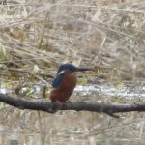
Kingfisher between Delnapot and Blacksboat, 11 March 2017 (Neil Sutherland & Carol Armour)
11/3/2017 Lesser Redpoll 70-80 Blacksboat-Knockando Neil Sutherland & Carol Armour
11/3/2017 Grey Wagtail 1 Knockando Neil Sutherland & Carol Armour
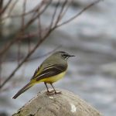
Grey Wagtail, Knockando 11 March 2017 (Neil Sutherland & Carol Armour)
11/3/2017 Goldeneye 7 (4 male, 3 female), Pied Wagtail 2 (a pair) Blacksboat (River Spey) Neil Sutherland & Carol Armour
11/3/2017 Ringed Plover 4 Findhorn dunes Richard Somers Cocks
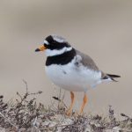
Ringed Plover, Findhorn dunes 11 March 2017 (Richard Somers Cocks)
11/3/2017 Black-throated Diver 7, Great Northern Diver 1, Red-throated Diver 1, Slavonian Grebe 3, Red-breasted Merganser 26 Burghead Bay (off Findhorn dunes) Richard Somers Cocks
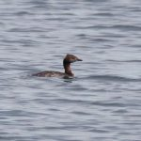 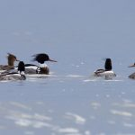 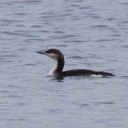
Slavonian Grebe, Red-breasted Mergansers and Black-throated Diver off Findhorn dunes, 11 March 2017 (Richard Somers Cocks)
11/3/2017 Glaucous Gull 1 (juvenile - flew off east), Iceland Gull 1 (juvenile), Knot 2, Bar-tailed Godwit 3, Wigeon 1120, Teal 45 Lossie estuary Bob Proctor
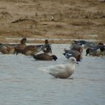
Iceland Gull, Lossie estuary 11 March 2017 (Bob Proctor)
11/3/2017 (08:10-09:10) Great Northern Diver 1, Red-throated Diver 1, Shelduck 1, Long-tailed Duck 36, Common Scoter 2, Gannet 79, Razorbill 22, Guillemot 3, Black Guillemot 1 past Lossiemouth in 1 hour Bob Proctor
11/3/2017 Rock Pipit 3, Grey Wagtail 1, Red-breasted Merganser 2 Burghead Mike Crutch
11/3/2017 Turnstone 33, Purple Sandpiper 1, Redshank 31 Burghead harbour Mike Crutch
11/3/2017 Lesser Redpoll 4 on feeders Elgin (Pluscarden Road) Alan Price
10/3/2017 Waxwing 41, Blackcap 1 (female) Elgin (west end) David Main
10/3/2017 (16:20) Waxwing 8 Findhorn Foundation Park Saille Mawson
10/3/2017 Merlin 1 Findhorn Bay Richard Somers Cocks, Gordon McMullins
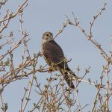
Merlin, Findhorn Bay 10 March 2017 (Richard Somers Cocks)
10/3/2017 Twite 37 Findhorn Bay (Netherton area) Gordon McMullins
10/3/2017 Black Redstart 1 Spey Bay (still in the new housing development NJ356652) per Birdguides
9/3/2017 Merlin 1 Findhorn Bay (Netherton area) Gordon McMullins
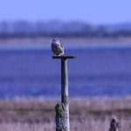
Merlin, Findhorn Bay 9 March 2017 (Gordon McMullins)
9/3/2017 Waxwing 28, Blackcap 1 (female) Elgin (west end) David Main
9/3/2017 Whooper Swan 37 Pitgaveny (in grass field, half mile SE of Pitgaveny-Loch Spynie road) Tony Backx
8/3/2017 (15:20) Green-winged Teal 1 (male) Loch Flemington per Birdguides
8/3/2017 Waxwing 48, Blackcap 1 (female) Elgin (west end) David Main
8/3/2017 Waxwing 15 Forres (by Grantown Road at Knockomie) per Birdguides
8/3/2017 Shoveler 1 (female), Scaup 1 (male), Coot 37, Stock Dove 1 Loch Spynie Roy Dennis
8/3/2017 Iceland Gull 1 (juvenile) Balormie pig farm (NJ2168) Roy Dennis
8/3/2017 Waxwing 8 Forres (by Grantown Road at Knockomie) Allan Lawrence
8/3/2017 Razorbill 146 (mostly breeding plumage adults, flew west in 10 minutes), Shelduck 3, Velvet Scoter 1 Burghead Roy Dennis
7/3/2017 Iceland Gull 1 (juvenile) Lossie estuary David Main
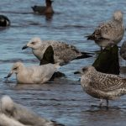
Iceland Gull, Lossie estuary 7 March 2017 (David Main)
7/3/2017 Waxwing 32, Blackcap 1 (female) Elgin (west end) David Main
7/3/2017 Purple Sandpiper 4 Lossiemouth (behind Beach Bar) Lisa Stewart
7/3/2017 Goosander 2 Elgin (on River Lossie) Lisa Stewart
7/3/2017 Waxwing 35 Elgin (East Back Street) Lisa Stewart
7/3/2017 Slavonian Grebe 3, Red-throated Diver 3 Burghead Bay (off Findhorn dunes) Richard Somers Cocks
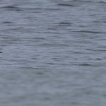
Slavonian Grebes, Burghead Bay 7 March 2017 (Richard Somers Cocks)
7/3/2017 Common Scoter 113, Velvet Scoter 6 Burghead Bay (off Findhorn dunes) Mike Crutch
7/3/2017 Peregrine 1 Findhorn Bay Mike Crutch
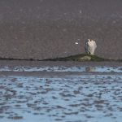
Peregrine, Findhorn Bay 7 March 2017 (Mike Crutch)
7/3/2017 Whooper Swan 19 Scarffbanks (NJ2466) Mike Collins, Martin Cook
7/3/2017 Whooper Swan 9 Foresterseat (NJ2563) Mike Collins, Martin Cook
7/3/2017 Red-throated Diver 7 Spey Bay (Boar's Head Rock area) Mike Collins, Martin Cook
7/3/2017 Goldeneye 16 Loch na Bo Mike Collins, Martin Cook
7/3/2017 Black Redstart 1 Spey Bay (still among rubble in the new housing development NJ356652) Mike Collins, Martin Cook
7/3/2017 Grey Plover 1, Dunlin 135, Shelduck 8, Goldeneye 17, Grey Wagtail 1 Spey estuary Mike Collins, Martin Cook
6/3/2017 Red-necked Grebe 1 Burghead Bay (off Findhorn dunes) John Poyner
6/3/2017 Slavonian Grebe 3 Burghead Bay (off Findhorn dunes) Richard Somers Cocks
6/3/2017 Velvet Scoter 16, Common Scoter 80, Long-tailed Duck 130 Burghead Bay (off Findhorn dunes) Mark Warren
6/3/2017 Waxwing 15 Burghead (High Street) Mark Warren
6/3/2017 Iceland Gull 2 (adult, juvenile) Balormie pig farm (NJ2168) Mark Warren
6/3/2017 Great Skua 1 (flew past), Grey Plover 1 Spey estuary Mark Warren
6/3/2017 Waxwing 41, Blackcap 2 Elgin (west end) David Main
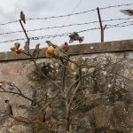
Waxwings, Elgin 6 March 2017 (David Main)
6/3/2017 Goosander 1 (male) Lossie estuary Gordon Biggs
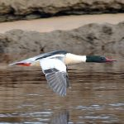
Goosander, Lossie estuary 6 March 2017 (Gordon Biggs)
6/3/2017 (09:30) Pink-footed Goose 510+ Delnies and 700+ flew east Cawdor Mike Crutch
5/3/2017 Lesser Black-backed Gull 1 (adult) Balormie pig farm Bob Proctor
5/3/2017 Green-winged Teal 1 (male) Loch Flemington Jon Clarke
5/3/2017 (08:15-09:15) Red-throated Diver 4, Gannet 34, Long-tailed Duck 24, Black Guillemot 3 past Lossiemouth in 1 hour Bob Proctor
5/3/2017 Iceland Gull 2 (2nd winter, 3rd winter) Lossie estuary Duncan Gibson
5/3/2017 Fieldfare 75 Muirton (NJ2268) Duncan Gibson
5/3/2017 Fieldfare 81, Redwing 17 Tomnamoon (NJ0449) Mike Crutch
5/3/2017 (13:00) Woodcock 1 Fochabers (on verge of A96) Alex Gordon
5/3/2017 Iceland Gull 1 (3rd winter) Lossie estuary David Main
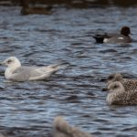
Iceland Gull, Lossie estuary 5 March 2017 (David Main)
5/3/2017 Water Rail 1 Elgin (The Wards) David Main
5/3/2017 Waxwing 7, Blackcap 1 (female) Elgin (west end) David Main
5/3/2017 European White-fronted Goose 1, Pink-footed Goose 644 Findhorn Bay (near mouth of Mosset Burn NJ0461) Richard Somers Cocks
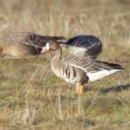
White-fronted Goose, Findhorn Bay 5 March 2017 (Richard Somers Cocks)
5/3/2017 Sanderling 28, Purple Sandpiper 14, Turnstone 12 Covesea lighthouse beach Lisa Stewart
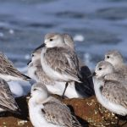 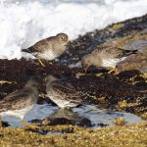
Sanderling and Purple Sandpipers, Covesea beach 5 March 2017 (Lisa Stewart)
5/3/2017 Common Scoter 80+, Goldeneye 2, Eider c.20, Fulmar 12 (on stacks) Cummingston Tony Backx
4/3/2017 Brambling c.20 Pitgaveny woods Duncan Gibson
4/3/2017 Siskin 34 on garden feeders Clochan (NJ4060) Martin Cook
4/3/2017 Waxwing 5 Elgin (west end) David Main
3/3/2017 Ptarmigan 2, Raven 2 Ben Rinnes Mike Crutch
3/3/2017 Greylag Goose 57 Tomdow (NJ0045) Mike Crutch
3/3/2017 Pink-footed Goose 96, Greylag Goose c.60 Nairn (just east of Sainsburys) Chris James & John Scrimgeour
3/3/2017 Bar-tailed Godwit 4 Lossie estuary Chris James & John Scrimgeour
3/3/2017 Waxwing 1 Burghead (main street) Chris James & John Scrimgeour
3/3/2017 Teal 43, Merlin 1 Findhorn Bay (in/near Mosset Burn) Chris James & John Scrimgeour
3/3/2017 (10:30) Black Redstart 1 Spey Bay (at western end of construction site) per Birdguides
3/3/2017 Knot 2 Lossie estuary Jack Harrison
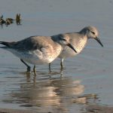
Knot, Lossie estuary 3 March 2017 (Jack Harrison)
3/3/2017 Yellowhammer 48, Corn Bunting 1 Burghead (north-east corner NJ124691) Martin Cook
3/3/2017 Common Scoter 184, Eider 90, Goldeneye 3 between Burghead-Hopeman Martin Cook
3/3/2017 Black-throated Diver 2, Common Scoter 142, Long-tailed Duck 39 Burghead Bay (off Findhorn dunes) Martin Cook
3/3/2017 Goldeneye 23, Grey Plover 1 Spey estuary Martin Cook
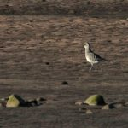
Grey Plover on the Spey estuary, 3 March 2017 (Martin Cook)
3/3/2017 Goldeneye 13 Nether Dallachy gravel pit (NJ370640) Martin Cook
3/3/2017 Merlin 1 Findhorn Bay (near mouth of Mosset Burn) Martin Cook, Richard Somers Cocks
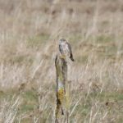
Merlin, Findhorn Bay 3 March 2017 (Richard Somers Cocks)
3/3/2017 Scaup 1 Findhorn Bay (off Findhorn village piers) Gordon McMullins, Richard Somers Cocks
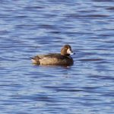
Scaup off Findhorn village, 3 March 2017 (Richard Somers Cocks)
2/3/2017 Iceland Gull 1 (juvenile) Lossie estuary per Birdguides
2/3/2017 Fieldfare 80 Tomnamoon (NJ0449) Mike Crutch
2/3/2017 Common Scoter 120, Velvet Scoter 4, Red-breasted Merganser 4 Burghead Bay (off Findhorn dunes) Mike Crutch
2/3/2017 Little Egret 1, Jack Snipe 1 Kingsteps (Nairn) Roy Dennis
2/3/2017 (12:15) Waxwing 12 Burghead (in tree opposite Forest Road junction on Grant Street) per Birdguides
2/3/2017 (12:00) Whooper Swan 27 Gordonsward (NJ254644) Chris Thomas
1/3/2017 Goosander 2 (a pair) Mosset Burn in Forres Ian Bailey
1/3/2017 Goosander 4 (2 male, 2 female) Sanquhar Loch (Forres) Karen Guthrie
1/3/2017 Sanderling 9 Nairn east beach Chris James & John Scrimgeour
1/3/2017 Brent Goose 65 Nairn west beach and later inside Nairn Bar Chris James & John Scrimgeour, and Beryl Blackhall
1/3/2017 Little Egret 1 Kingsteps (NH9057) Beryl Blackhall
1/3/2017 Bar-tailed Godwit 23 Burghead Tony Backx
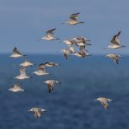 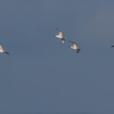
Bar-tailed Godwits at Burghead, 1 March 2017 (Tony Backx)
1/3/2017 Crossbill sp. 10 Pitchroy (NJ1738) Carol Armour & Neil Sutherland
1/3/2017 Snow Bunting 1 Lossiemouth east beach Mike Murray
1/3/2017 Redwing 4 Cooper Park (Elgin) Lisa Stewart
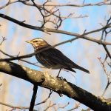
Redwing, Cooper Park 1 March 2017 (Lisa Stewart)

