31/3/2013 Wheatear 1 Tronach Head Lenny Simpson
31/3/2013 Black Guillemot 17 Portknockie (east of Bow Fiddle Rock) Lenny Simpson
30/3/2013 Black-tailed Godwit 1 Findhorn Bay Richard Somers Cocks
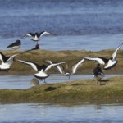
(Black-tailed Godwit with Oystercatchers, Findhorn Bay 30 March 2013. Photo: Richard Somers Cocks)
30/3/2013 Yellowhammer 20, Reed Bunting 4 South Darkland David Law
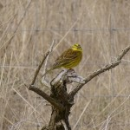
(Yellowhammer at South Darkland, 30 March 2013. Photo: David Law)
30/3/2013 Waxwing 34 Elgin (Bishopmill) David Main
29/3/2013 Black-tailed Godwit 3 Lossie estuary Charlie Gervaise
29/3/2013 Grey Plover 1 Lossiemouth west beach Charlie Gervaise
29/3/2013 Iceland Gull 2 adults Loch Oire Martin Cook
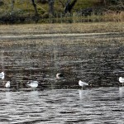
(Two Iceland Gulls [extreme right and extreme left], Loch Oire 29 March 2013. Photo: Martin Cook)
28/3/2013 Black-throated Diver 2 Findhorn Gordon McMullins
28/3/2013 Mediterranean Gull 1 2nd winter Loch Oire David Devonport
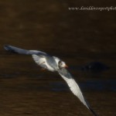
(Mediterranean Gull [2nd winter] at Loch Oire, 28 March 2013. Photo: David Devonport)
28/3/2013 Iceland Gull 1 2nd winter, Black-throated Diver 1 Kingston Martin Cook
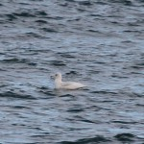
(Iceland Gull [2nd winter] off Kingston, 28 March 2013. Photo: Martin Cook)
28/3/2013 Iceland Gull 2 adults Loch Oire David Devonport, Martin Cook
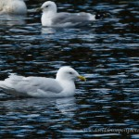
(Iceland Gull [adult] at Loch Oire, 28 March 2013. Photo: David Devonport)
28/3/2013 Waxwing 18 Elgin (Bishopmill) David Main
26/3/2013 Gadwall 2 (a pair), Goldeneye 45 Loch na Bo Martin Cook
26/3/2013 Waxwing 32 Elgin (Bishopmill) David Main
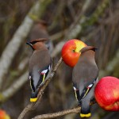
(Waxwings feasting on apples, Bishopmill 26 March 2013. Photo: David Main)
25/3/2013 Glaucous Gull 1 juv Hopeman (in pig fields) per Birdguides
25/3/2013 Waxwing 28 Elgin (Bishopmill) David Main
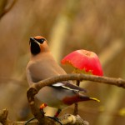
(Colour ringed Waxwing in Bishopmill, 23 March 2013. This bird was ringed in Aberdeen on 1 November 2012. Photo: David Main)
25/3/2013 Sandwich Tern 1 Findhorn Bay Gordon McMullins
25/3/2013 Fieldfare 60 North Alves Tony Backx
24/3/2013 Whooper Swan 48, Canada Goose 1 Wester Calcots Dick Hewitt
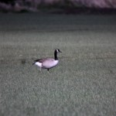
(Canada Goose, Wester Calcots March 2013. Photo: Dick Hewitt)
24/3/2013 Waxwing 32 Elgin (Bishopmill) David Main
23/3/2013 Brambling 6 Keith Hugh Clark
23/3/2013 Brambling 1 South Darkland David Law
23/3/2013 Waxwing 2 Findhorn Gordon McMullins
23/3/2013 Mandarin Duck 1 male Elgin (Cooper Park) Charlie Gervaise
23/3/2013 Grey Plover 1, Puffin 1 Lossiemouth west beach Charlie Gervaise
23/3/2013 Brambling 9 at Niger seed Clochan Martin Cook
23/3/2013 Yellowhammer 15 Rafford (in a garden) Gordon Biggs
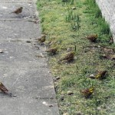
(Yellowhammers in a Rafford garden, 23 March 2013. Photo: Gordon Biggs)
23/3/2013 Waxwing 32 Elgin (Bishopmill) David Main
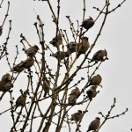
(Waxwings in Bishopmill, 23 March 2013 [details of colour-ringed bird to follow]. Photo: David Main)
22/3/2013 Waxwing c50 Elgin (Marleon Field) Bob Proctor
22/3/2013 Waxwing c20 Lossiemouth (Clifton Road) Gordon Biggs
22/3/2013 Waxwing 58, Blackcap 1 female Elgin (Bishopmill) David Main
22/3/2013 Brambling 7 Clochan Martin Cook
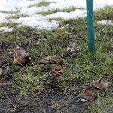
(Seven Bramblings [4 male, 3 female] with a Chaffinch, Clochan 22 March 2013. Photo: Martin Cook)
21/3/2013 Waxwing 18 Elgin (Bishopmill) David Main
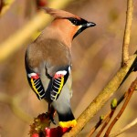
(Waxwing displaying the waxy red feather tips which give the species its name, Elgin 21 March 2013. Photo: David Main)
21/3/2013 Iceland Gull 2 adults Loch Oire Martin Cook
21/3/2013 Brambling 2 Cairnfield (Buckie) Hugh Clark
20/3/2013 Twite c100 Netherton (Findhorn Bay) Gordon Biggs
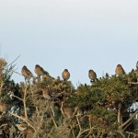
(Twite at Netherton, 20 March 2013. Photo: Gordon Biggs)
20/3/2013 Slavonian Grebe 1 Kingston David Main
20/3/2013 Snow Bunting 1 Findhorn (Dinghy Park) Gordon McMullins
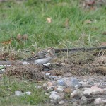
(Snow Bunting in Findhorn Dinghy Park, 20 March 2013. Photo: Gordon McMullins)
18/3/2013 Mandarin Duck 1 male Elgin (Cooper Park) Charlie Gervaise
18/3/2013 Whooper Swan 72, Canada Goose 1 Pitairlie Charlie Gervaise
17/3/2013 Iceland Gull 1 adult Loch Oire Martin Cook
17/3/2013 Waxwing 43 Elgin (Johnstons woollen mill entrance) Bob Proctor
17/3/2013 Mandarin Duck 1 male Elgin (Cooper Park) Bob Proctor
16/3/2013 Black-throated Diver 3 off Tugnet (Spey Bay) Martin Cook
16/3/2013 Mandarin Duck 1 male Elgin (Cooper Park) Bob Proctor
16/3/2013 Whooper Swan 27 Pitairlie Bob Proctor
15/3/2013 Waxwing c50 Elgin (near railway station) Charlie Gervaise
15/3/2013 Brent Goose 62 Nairn west beach Charlie Gervaise
14/3/2013 Waxwing 15 Elgin (Bishopmill) Allan Lawrence
14/3/2013 Slavonian Grebe 2, Great Northern Diver 1 Findhorn Richard Somers Cocks
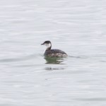
(Slavonian Grebe off Findhorn, 14 March 2013. Photo: Richard Somers Cocks)
14/3/2013 Waxwing 30+ Elgin (Maisondieu Rd) David Main
14/3/2013 Iceland Gull 1, Lesser Black-backed Gull 1 Loch Oire Eddie Harwood
13/3/2013 Iceland Gull 2 adults, Lesser Black-backed Gull 1 Loch Oire David Devonport
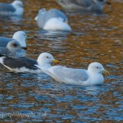 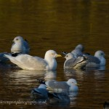
(Lesser Black-backed Gull with Iceland Gull [left], and the second Iceland Gull [right] on Loch Oire on 13 March 2013. Photo: David Devonport)
13/3/2013 Twite 65, Greenshank 1 Netherton (Findhorn Bay) Richard Somers Cocks
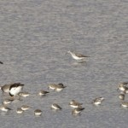
(Greenshank [centre] with Dunlin, 2 Oystercatchers and a Redshank in Findhorn Bay on 13 March 2013. Photo: Richard Somers Cocks)
13/3/2013 Brambling 1 male Clochan Martin Cook
11/3/2013 Mandarin Duck 1 male Elgin (Cooper Park) Mark Whitton
10/3/2013 Grey Partridge 2 Netherton (Findhorn Bay) Gordon Biggs
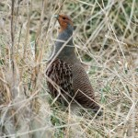
(Grey Partridge at Netherton, 10 March 2013. Photo: Gordon Biggs)
10/3/2013 Snow Bunting 25 Nairn east beach (nr. Dunbar golf club) per Birdguides
10/3/2013 Blackcap 1 female Elgin (Bishopmill) David Main
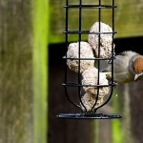
(Female Blackcap attracted to fat balls in an Elgin garden. Photo: David Main)
10/3/2013 Waxwing 38 Lossiemouth (Boyd Anderson Drive) Margaret Sharpe
9/3/2013 Waxwing 26 Lossiemouth (Boyd Anderson Drive) Margaret Sharpe
9/3/2013 Waxwing 20 Loch Spynie (top of track to Scarffbanks) Charlie Gervaise
9/3/2013 Lesser Black-backed Gull 1 Elgin (Cooper Park) Charlie Gervaise
9/3/2013 Twite 112 Netherton (Findhorn Bay) Gordon Biggs
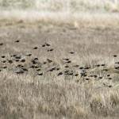
(Twite flock at Netherton, 9 March 2013. Photo: Gordon Biggs)
9/3/2013 Canada Goose 1, Whooper Swan 70 Pitairlie Bob Proctor
9/3/2013 Mandarin Duck 1 male Elgin (Cooper Park) Bob Proctor, Mark Whitton
8/3/2013 Fieldfare 50+, Woodcock 1 Cloddach David Main
8/3/2013 Waxwing 13 Duffus Jim Preston
8/3/2013 Iceland Gull 1 adult, Lesser Black-backed Gull 2 Loch Oire Martin Cook
7/3/2013 Gannet 1 adult Spey Bay Martin Cook
7/3/2013 Gannet 3 adults Findhorn Roy Dennis
7/3/2013 Smew 1 redhead Loch Spynie Bob Proctor
7/3/2013 Whooper Swan 9, Canada Goose 1 Muirton Bob Proctor
7/3/2013 Whooper Swan 54 Pitairlie Bob Proctor
7/3/2013 Blackcap 1 female Elgin (Bishopmill) David Main
7/3/2013 Waxwing 34 Elgin (Maisondieu Rd) David Main
7/3/2013 Waxwing 9 Loch Spynie (top of track to Scarffbanks) Margaret Sharpe
7/3/2013 Lesser Black-backed Gull 1 Spey estuary Martin Cook
5/3/2013 Long-tailed Duck 5 Findhorn Anne Maclean-Chang
5/3/2013 Short-eared Owl 2, Water Rail 1 Kinloss airfield Allan Lawrence
5/3/2013 Grey Partridge 2 Netherton (Richard Somers Cocks)
4/3/2013 Twite 70 Netherton (Findhorn Bay) Roy Dennis
4/3/2013 Razorbill 80+ fishing Burghead Roy Dennis
6/3/2013 Lesser Black-backed Gull 3 Lossie estuary Bob Proctor
6/3/2013 Canada Goose 1, Whooper Swan 9 Muirton Bob Proctor
6/3/2013 Smew 1 redhead, Lesser Black-backed Gull 1 Loch Spynie Bob Proctor
6/3/2013 Whooper Swan 52 Pitairlie Bob Proctor
6/3/2013 Waxwing 26 Lossiemouth (Boyd Anderson Drive) Margaret Sharpe
5/3/2013 Bar-tailed Godwit c60 Burghead Gordon Biggs
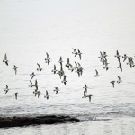
(Bar-tailed Godwits just east of Burghead on 5 March 2013. Photo: Gordon Biggs)
5/3/2013 Whooper Swan 21 Loch Spynie Gordon Biggs
5/3/2013 Smew 1 redhead, Iceland Gull 1 (1st winter) Loch Spynie Duncan Gibson
5/3/2013 Waxwing 5 Lossiemouth (Boyd Anderson Drive) Margaret Sharpe
5/3/2013 Twite 35 Netherton (Findhorn Bay) Martin Cook, Mike Collins
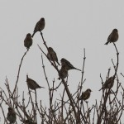
(Twite beside the saltmarsh at Netherton, 5 March 2013. Photo: Martin Cook)
5/3/2013 Black-throated Diver 2, Great Northern Diver 1 off Findhorn Martin Cook, Mike Collins
5/3/2013 Black-throated Diver 4 off Tugnet Martin Cook, Mike Collins
4/3/2013 Bittern 1, Smew 1 redhead Loch Spynie Hugo Shannon
4/3/2013 Mandarin Duck 1 male Elgin (Cooper Park pond) Mark Whitton
4/3/2013 Pied Wagtail 38 Elgin-Lossiemouth old railway line (in a newly-ploughed field) David Main
4/3/2013 Snowy Owl 1 immature male Cairngorms per Birdguides
4/3/2013 Great Northern Diver 1 Findhorn Richard Somers Cocks
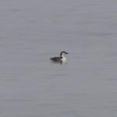
(Great Northern Diver off Findhorn, 4 March 2013. Photo: Richard Somers Cocks)
3/3/2013 Smew 1 redhead Loch Spynie Duncan Gibson
3/3/2013 Iceland Gull 1 adult Lossie estuary Duncan Gibson
3/3/2013 Oystercatcher 11 Dufftown Fiona McHugh
3/3/2013 Waxwing 16 Elgin (Sandy Road) Fiona McHugh
3/3/2013 Whooper Swan 50, Canada Goose 1 Muirton Charlie Gervaise, Bob Proctor
2/3/2013 Waxwing 3 Dufftown Dave Wheeler
2/3/2013 Mandarin Duck 1 male Elgin (Cooper Park pond) Charlie Gervaise
2/3/2013 Whooper Swan 40, Canada Goose 1 Muirton Charlie Gervaise
1/3/2013 Waxwing 10 Elgin (The Wards) Yvonne Watson
1/3/2013 Whooper Swan 35+, Canada Goose 1 Muirton Yvonne Watson
1/3/2013 Snowy Owl 1 Cairngorms Martin Cook
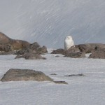
(Snowy Owl in the Cairngorms, 1 March 2013. Photo: Martin Cook)
1/3/2013 Waxwing 9 Forres (bypass nr. Christies Nursery) Mark Whitton

