31/8/2016 Peregrine 1 Burghead Tony Backx
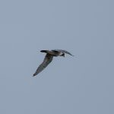
Peregrine, Burghead 31 August 2016 (Tony Backx)
31/8/2016 Teal 160 Findhorn Bay (mouth of Mosset Burn NJ0461) Roy Dennis
31/8/2016 Hobby 1 Tugnet (mouth of River Spey, over Scottish Dolphin Centre car park NJ3465) Toby Green
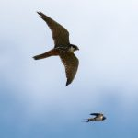
Hobby over Tugnet, 31 August 2016 (Toby Green)
31/8/2016 Common Tern 23, Sandwich Tern 12 Findhorn beach Richard Somers Cocks
31/8/2016 Black-tailed Godwit 15, Greenshank 1, Canada Goose 16 Findhorn Bay (south end) Gordon McMullins
31/8/2016 Barnacle Goose 1 Kingsteps (at Minister's Pool) Chris James & John Scrimgeour
31/8/2016 Bar-tailed Godwit 26, Sanderling 2, Sandwich Tern 112 (on east beach), Turnstone 18, Grey Wagtail (at river mouth) Nairn Chris James & John Scrimgeour
31/8/2016 Water Rail 1 Loch Spynie Lisa Stewart
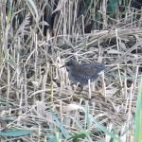
Water Rail at Loch Spynie, 31 August 2016 (Lisa Stewart)
31/8/2016 Little Stint 1, Knot 5, Dunlin 80, Redshank 13, Turnstone 24, Goosander 371, Wigeon 6, Wheatear 2, Linnet c.200 Spey estuary (east side) Martin Cook
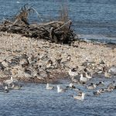 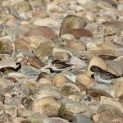
Goosanders and Little Stint, Spey estuary 31 August 2016 (Martin Cook)
31/8/2016 Little Grebe 27, Wigeon 4, Tufted Duck 56 Loch Spynie Martin Cook
30/8/2016 Red-throated Diver 8 Spey Bay (off golf course) Mike Collins
30/8/2016 Sanderling 29, Wheatear 1 Hopeman Alison Ritchie
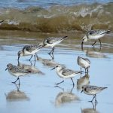 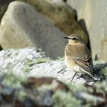
Sanderling and Wheatear, Hopeman 30 August 2016 (Alison Ritchie)
30/8/2016 Black-tailed Godwit 52, Bar-tailed Godwit 1, Knot 60, Ringed Plover 45, Dunlin 272, Redshank 572 Findhorn Bay (south end) Gordon McMullins
29/8/2016 Water Rail 1 (juvenile) Loch Spynie Lisa Stewart
29/8/2016 Whimbrel 1 (flew east), Knot 35 Burghead (north shore) Tony Backx
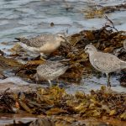
Knot on Burghead shore [3 juveniles and 1 adult (second from right)], 29 August 2016 (Tony Backx)
28/8/2016 Wheatear 1, Magpie 1 Newland of Delnies (Nairn) Simon Foster
28/8/2016 Kingfisher 1 Loch Oire Ryan Simpson
28/8/2016 Jay 7 together, Stock Dove 1 Darkland (NJ2661) David Law
28/8/2016 Green Sandpiper 1 Montgrew pool (Keith NJ4551) Melvin Morrison
28/8/2016 Crested Tit 1 Binn Hill (Kingston NJ3165) Martin & Jenny Cook
28/8/2016 Goosander 406 mouth of River Spey Martin & Jenny Cook
28/8/2016 Curlew Sandpiper 2, Dunlin c.140, Ringed Plover c.60, Snipe 2, Wheatear 5 Spey estuary (west side) Martin & Jenny Cook
28/8/2016 Whimbrel 6 flew west (4, 1, 1 over 30 minutes), Wheatear 1 Kingston (Lein) Martin & Jenny Cook
28/8/2016 Whimbrel 6 Hopeman east beach Alastair Millar
28/8/2016 Razorbill 4, Fulmar 3 Burghead Bay (off Findhorn beach) Richard Somers Cocks
28/8/2016 Whimbrel 3 (flew west), Knot 97 Findhorn beach Richard Somers Cocks
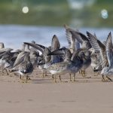
Knot on Findhorn beach, 28 August 2016 (Richard Somers Cocks)
28/8/2016 Knot 76 Findhorn Bay (off bird hide) Richard Somers Cocks
28/8/2016 Common Scoter 41, Eider 61, Goosander 56, Red-throated Diver 3 Burghead Bay (from Roseisle FC car park NJ1065) Richard Somers Cocks
27/8/2016 Ringed Plover 12, Wigeon 2 Lossie estuary Lisa Stewart
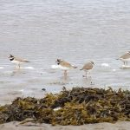
Ringed Plovers, Lossie estuary 27 August 2016 (Lisa Stewart)
27/8/2016 Sanderling 4, Wheatear 1 Covesea beach Margaret Sharpe
27/8/2016 Sandwich Tern 25, Common Tern 24, Black Guillemot 2 (flew east) Findhorn beach Richard Somers Cocks
27/8/2016 Golden Plover 1, Ringed Plover 28, Bar-tailed Godwit 2, Peregrine 1 Findhorn Bay Richard Somers Cocks
27/8/2016 Greenshank 7, Little Grebe 6 (in old Findhorn channel), Canada Goose 16, Common Sandpiper 2, Snipe 4 Findhorn Bay (south-west corner) Gordon McMullins
27/8/2016 Wheatear 2 (just east of maltings), Stonechat 1, Turnstone 13, Knot 4 Burghead (north shore) Geoff & Debbie Smith
27/8/2016 (11:00) Green Sandpiper 1 Montgrew pool (Keith NJ4551) Martin Cook
26/8/2016 (18:40-20:10) Arctic Skua 2, Great Skua 2, Kittiwake 1084, Sandwich Tern 97, Common Tern 6, Black Guillemot 2, Gannet 273, Manx Shearwater 4, Fulmar 17 past Lossiemouth in 90 minutes Bob Proctor
26/8/2016 Goosander 312, Teal 52, Wigeon 2, Whimbrel 5, Curlew 90, Ringed Plover 28, Dunlin 59, Turnstone 29, Oystercatcher 9, Lapwing 3 Spey estuary (west side) Martin Cook
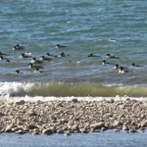
Part of the huge Goosander flock off the mouth of the Spey, 26 August 2016 (Martin Cook)
26/8/2016 Eider 26 Spey Bay (off Tugnet) Martin Cook
26/8/2016 Greenshank 1, Knot 17, Turnstone 11, Redshank c.20 Burghead Tony Backx
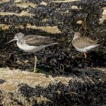
Greenshank [with Redshank], Burghead 26 August 2016 (Tony Backx)
26/8/2016 Red Kite 1 over A96 near Auldearn David & Carol Shaw
25/8/2016 Little Stint 1, Greenshank 1, Redshank 794 Findhorn Bay (south end) Gordon McMullins
25/8/2016 Green Sandpiper 1, Common Sandpiper 2 Mosset Burn at Findhorn Bay (NJ0461) Gordon McMullins
25/8/2016 Whimbrel 1, Curlew 100+, Golden Plover 2, Osprey 2 Spey estuary (west side) Chris James & John Scrimgeour
25/8/2016 Knot 2, Dunlin 3 Burghead Mike Crutch
25/8/2016 Osprey 4 Findhorn Bay Mike Crutch
25/8/2016 House Martin c.250 over Lethen (NH9451) Jack Harrison
25/8/2016 Golden Plover 9 Knockan (above Drummuir NJ3546) David Main
24/8/2016 Water Rail 1 juvenile Loch Spynie Lisa Stewart
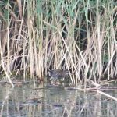
Juvenile Water Rail at Loch Spynie, 24 August 2016 (Lisa Stewart)
24/8/2016 Common Tern 16, Grey Heron 8, Wigeon 1 Lossie estuary Dave Wheeler
24/8/2016 Arctic Skua 1 off Findhorn beach Mike Crutch
24/8/2016 Kingfisher 1 Loch Oire Eddie Harwood
23/8/2016 Mandarin Duck 1 Loch Oire Eddie Harwood
23/8/2016 Goosander 244, Snipe 7, Golden Plover 3 Spey estuary (west side) Chris James, John Scrimgeour
23/8/2016 Kingfisher 1 Elgin (on River Lossie just upstream from Mansion House Hotel) Moray Mackay
22/8/2016 Black-tailed Godwit 39, Knot 47, Dunlin 335, Golden Plover 4, Teal 10, Peregrine 1 Findhorn Bay Gordon McMullins
22/8/2016 Greenshank 3, Redshank 12, Dunlin 6, Kestrel 1, Osprey 1 Lossie estuary Henry Farquhar
22/8/2016 Knot 4 Burghead David & Carol Shaw
22/8/2016 Wood Sandpiper 1 (but flew off high), Teal 72 Montgrew pool (Keith NJ4551) Martin Cook
22/8/2016 Greenshank 1, Redshank 4, Whimbrel 1, Sanderling 3, Ringed Plover 56, Dunlin 79, Turnstone 31, Teal 62, Wigeon 4 Spey estuary (west side) Martin Cook
22/8/2016 Black Guillemot 1 Findhorn (off piers in front of the village NJ0364) Richard Somers Cocks
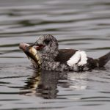
Black Guillemot off Findhorn, 22 August 2016 (Richard Somers Cocks)
21/8/2016 Green Sandpiper 1 Montgrew pool (Keith NJ4551) Melvin Morrison
21/8/2016 Turnstone 10 Findhorn village shore Richard Somers Cocks
21/8/2016 Common Sandpiper 5, Snipe 3, Grey Wagtail 2 Findhorn Bay (on Mosset Burn close to the road NJ0461) Richard Somers Cocks
21/8/2016 Kittiwake 780, Sandwich Tern 34, Common Tern 36, Arctic Tern 4 Findhorn beach Richard Somers Cocks
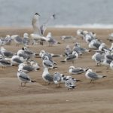
Kittiwakes on Findhorn beach, 21 August 2016 (Richard Somers Cocks)
21/8/2016 Canada Goose 16, Red-breasted Merganser 9, Goosander 7, Grey Heron 11, Osprey 7, Oystercatcher 539, Redshank 635, Dunlin 221, Ringed Plover 81, Black-tailed Godwit 1, Ruff 1 Findhorn Bay Richard Somers Cocks, Gordon McMullins
21/8/2016 Common Sandpiper 1, Snipe 1, Grey Wagtail 1 on Mosset Burn at Findhorn Bay (NJ0461) Allan Lawrence
21/8/2016 (09:20-10:20) Manx Shearwater 6, Fulmar 42, Gannet 192, Great Skua 1, Black Guillemot 6, Kittiwake 28, Sandwich Tern 4, Grey Heron 1 past Lossiemouth in 1 hour Bob Proctor
21/8/2016 Guillemot 8 on sea off Lossiemouth harbour Bob Proctor
20/8/2016 Shelduck 10, Wigeon 23, Greenshank 3, Knot 44, Curlew 349, Bar-tailed Godwit 1, Peregrine 1 Findhorn Bay Richard Somers Cocks, Gordon McMullins
20/8/2016 Goldfinch c.50, crossbill sp. 3 Darkland David Law
20/8/2016 Pintail 6, Common Sandpiper 2 (in Mosset Burn) Findhorn Bay Roy Dennis
20/8/2016 Little Stint 1, Sanderling 3, Dunlin 142, Ringed Plover 113, Turnstone 22, Redshank 5, Common Sandpiper 2, Goosander 45, Teal 30, Wigeon 1, Common Scoter 2 Spey estuary (west side) Martin Cook
19/8/2016 Turnstone 11, Curlew 2 Burghead Tony Backx
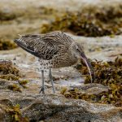
Curlew at Burghead, 19 August 2016 (Tony Backx)
19/8/2016 Swift 2 Burghead Bob Johnson
19/8/2016 Common Tern 165, Sandwich Tern 48, Kittiwake 230 Findhorn beach Richard Somers Cocks
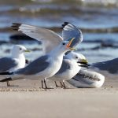
Kittiwakes on Findhorn beach, 19 August 2016 (Richard Somers Cocks)
19/8/2016 Turnstone 26, Knot 7, Dunlin 60, Goosander 72 Spey estuary (east side) Martin Cook
19/8/2016 Spotted Flycatcher 2+ Tilliglens (NJ0046) Mike Crutch
18/8/2016 Wheatear 1 Burghead Bob Johnson
18/8/2016 Curlew c.150 Corskie (Garmouth) David Law
18/8/2016 Ruff 4, Dunlin 14, White Wagtail 1 Balormie pig farm Bob Proctor
18/8/2016 Canada Goose 16, Greylag Goose 347, Goldeneye 2 Findhorn Bay (south end) Richard Somers Cocks
18/8/2016 Goosander 33, Common Tern 154, Arctic Tern 2, Sandwich Tern 27, Kittiwake 115, Great Skua 1 Findhorn beach Richard Somers Cocks
18/8/2016 Greenshank 5, Redshank 434, Knot 6, Common Sandpiper 3, Common Tern 142, Little Grebe 4, Canada Goose 16, Greylag Goose 123, Findhorn Bay (south-west corner, Mosset Burn to old Findhorn channel) Gordon McMullins
18/8/2016 Ringed Plover 23, Dunlin 39, Sanderling 1 Findhorn beach Geoff & Debbie Smith
17/8/2016 Green Sandpiper 1 Montgrew pool (Keith NJ4551) Martin Cook, Melvin Morrison
17/8/2016 Little Stint 1, Ruff 4, Ringed Plover 105, Dunlin 54, Knot 1, Snipe 9, Redshank 4, Teal 11 Spey estuary (west side) Martin & Jenny Cook
17/8/2016 Canada Goose 16, Wigeon 21, Red-breasted Merganser female with 7 ducklings, Osprey 7 Findhorn Bay (south-west corner) Gordon McMullins
16/8/2016 Sanderling 25, Ringed Plover 50+, Knot 1 Lossiemouth west beach Henry Farquhar
16/8/2016 Bar-tailed Godwit 11 (in front of caravan site), Turnstone 28, Wheatear 1, Grey Wagtail 1 Burghead Chris James
16/8/2016 Curlew 106, Sandwich Tern 2 between Burghead-Cummingston Chris James
16/8/2016 Ringed Plover 22, Goosander 38, Linnet c.200 Spey estuary Martin Cook
16/8/2016 Raven 9, Curlew 18 Tom Trumper (Glenlivet NJ2318-19) Martin Cook
16/8/2016 Black-tailed Godwit 30-35, Greenshank 3, Little Grebe 2, Canada Goose 16, Greylag Goose 127, Teal 3 Findhorn Bay (south-west corner, Mosset Burn to old Findhorn channel) Gordon McMullins
15/8/2016 Red-breasted Merganser 2 (on river), Redshank 5, Turnstone 2 (on harbour wall) Nairn Seamus McArdle
15/8/2016 Sandwich Tern 43, Common Tern 6, Osprey 7 Findhorn Bay Mike Crutch
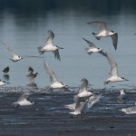 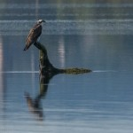
Sandwich Terns and Osprey, Findhorn Bay 15 August 2016 (Mike Crutch)
14-15/8/2016 Storm Petrel 21 (caught at night for ringing) Portknockie Alastair Young
14/8/2016 Greenshank 4, Goosander 6 Lossie estuary Henry Farquhar
14/8/2016 Black-tailed Godwit 5, Greenshank 1, Ringed Plover c.118, Sandwich Tern 38, Greylag Goose c.124 Findhorn Bay Chris James
14/8/2016 Wheatear 4 Lein (Kingston NJ3365) Alex Gordon
13/8/2016 Mistle Thrush 37, Tawny Owl 3 Tomnamoon (NJ0449) Mike Crutch
13/8/2016 Whimbrel 2 (flew south), Goosander 8, Wigeon 1 Lossie estuary Bob Proctor
13/8/2016 (evening) Ruff 2 Findhorn Bay (south end NJ0462) Gordon McMullins
13/8/2016 Ruff 2, Redshank 230, Ringed Plover 154, Dunlin 88, Sanderling 6, Knot 1, Bar-tailed Godwit 1, Turnstone 1 (all off bird hide), Greenshank 1 (in south-west corner) Findhorn Bay Richard Somers Cocks
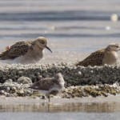 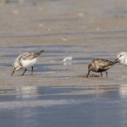 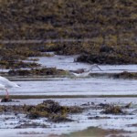
Ruff [left], Sanderling and Greenshank, Findhorn Bay 13 August 2016 (Richard Somers Cocks)
12/8/2016 Sanderling 1, Ringed Plover 16, Dunlin 1 Lossie estuary David Main
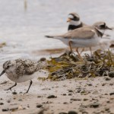
Sanderling with Ringed Plovers, Lossie estuary 12 August 2016 (David Main)
12/8/2016 Ringed Plover 72, Dunlin 40, Curlew 170, Lapwing 12 Spey estuary (west side) Martin Cook
12/8/2016 Goldeneye 2 (juveniles), Arctic Skua 6, Gannet 135+ off Findhorn beach Richard Somers Cocks
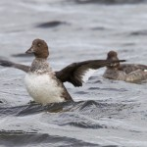 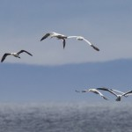
Juvenile Goldeneye, and Gannets, off Findhorn, 12 Aug 2016
11/8/2016 Greylag Goose 110 (in NH9757), Barn Owl (dead beside A96) Brodie Mike Crutch
11/8/2016 (19:30) Ruff 11, Dunlin 9, Lapwing 206, Greenshank 1, Stock Dove 1 Balormie pig farm (NJ2168) Bob Proctor
11/8/2016 (18:10-19:10) Manx Shearwater 1, Black Guillemot 14, Gannet 104, Fulmar 14 past Lossiemouth in 1 hour Bob Proctor
11/8/2016 Wigeon 2 Lossie estuary Bob Proctor
11/8/2016 Greenshank 2, Sandwich Tern 105 Findhorn Bay (south end) Roy Dennis
11/8/2016 Sanderling 13, Ringed Plover 18 Lossie estuary Roy Dennis
11/8/2016 Ruff 1 Balormie pig farm (NJ2168) Roy Dennis
11/8/2016 Arctic Skua 4, Little Tern 2, Common Tern 96, Arctic Tern 12, Sandwich Tern 14 Findhorn beach Richard Somers Cocks
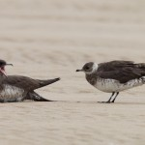
Arctic Skuas on Findhorn beach, 11 August 2016 (Richard Somers Cocks)
10/8/2016 Goosander 4 Lossie estuary Geoff & Debbie Smith
10/8/2016 Wigeon 2 Lossie estuary Bob Proctor
10/8/2016 Glaucous Gull 1 (1st summer), Turnstone 18 Spey estuary Gordon McMullins
10/8/2016 Sandwich Tern 120, Common Tern 32, Arctic Tern 20, Little Tern 2 Findhorn beach Richard Somers Cocks
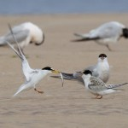
Little Terns on Findhorn beach, 10 August 2016 (Richard Somers Cocks)
10/8/2016 Arctic Skua 4 Burghead Bay Allan Lawrence
9/8/2016 Common Tern 2 Lossie estuary David Main
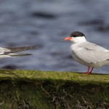
Common Terns, Lossie estuary 9 August 2016 (David Main)
9/8/2016 Ringed Plover 58, Dunlin 32 Spey estuary Martin Cook
8/8/2016 (18:30-19:30, 20:15-21:15) Manx Shearwater 75, Storm Petrel 1, Fulmar 144, Gannet 227, Great Skua 2, Kittiwake 331, Common Tern 27, Arctic Tern 14, Black Guillemot 5, Red-throated Diver 2, Shelduck 2, Turnstone 9 past Lossiemouth in 2 hours Bob Proctor
8/8/2016 Ruff 8, Dunlin 1 Balormie pig farm (NJ2168) Duncan Gibson
7/8/2016 Greenshank 5, Redshank 9, Common Sandpiper 4, Goosander 1, Kestrel 1 Lossie estuary and up river Chris James
7/8/2016 Ruff 9, Black-tailed Godwit 1, Dunlin 2 Balormie pig farm (NJ2168) Henry Farquhar, Duncan Gibson
6/8/2016 Curlew 133, Common Sandpiper 1, Little Grebe 23, Mute Swan pair with 10 cygnets Cloddach gravel pit Martin Cook
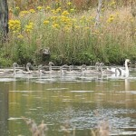
Large Mute Swan family, Cloddach 6 August 2016 (Martin Cook)
6/8/2016 (early morning) Greenshank 9, Common Sandpiper 5 Lossie estuary and up river Henry Farquhar
5/8/2016 (15:30) Ringed Plover 46 Spey estuary (east side) Martin Cook
5/8/2016 (10:00) Greenshank 1, Sanderling 6, Dunlin 25, Ringed Plover 27, Common Sandpiper 3, Turnstone 14 Spey estuary (west side) Martin Cook
5/8/2016 (07:00) Greenshank 7, Common Sandpiper 2 Lossie estuary Henry Farquhar
4/8/2016 Manx Shearwater 1, Arctic Skua 1, Kittiwake c.70 past Burghead Roy Dennis
4/8/2016 Little Stint 1, Dunlin 22, Greenshank 1, Ringed Plover 21, Turnstone 18, Lapwing 38, Common Sandpiper 2, Goosander 109, Common Tern 7, Arctic Tern 1, Sandwich Tern 6 Spey estuary (east side) Martin Cook
3-4/8/2016 Storm Petrel 3 caught for ringing Findochty Alastair Young
3-4/8/2016 Storm Petrel 3 caught for ringing Burghead Brian Bates
3/8/2016 Kingfisher 1 Loch Spynie Gordon Biggs
3/8/2016 Common Sandpiper 7 Lossie estuary Henry Farquhar
3/8/2016 Turnstone 13 Burghead David & Carol Shaw
3/8/2016 Curlew 80, Lapwing 10, Dunlin 35, Common Sandpiper 1 Spey estuary (west side) Martin Cook
2/8/2016 Turnstone c.10 Nairn Jack Harrison
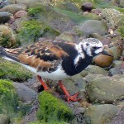
Turnstone at Nairn, 2 August 2016 (Jack Harrison)
2/8/2016 Turnstone 7, Knot 1 Burghead Tony Backx
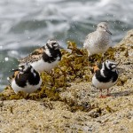
Turnstones with a Knot, Burghead 2 August 2016 (Tony Backx)
1-2/8/2016 Storm Petrel 6 caught for ringing Findochty Alastair Young
1-2/8/2016 (22:30-01:00) Storm Petrel 3 caught for ringing Strathlene (Buckie) Martin Cook
1/8/2016 Whimbrel 1 Netherton (Findhorn Bay) Mike Crutch
1/8/2016 Knot 26, Turnstone 2 Burghead Tony Backx
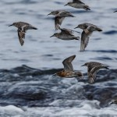 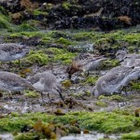
Knot at Burghead, 1 August 2016 (Tony Backx)
1/8/2016 Common Sandpiper 7, Snipe 1, Swift 3 Mosset Burn at Findhorn Bay Roy Dennis
1/8/2016 Greylag Goose 489, Curlew 397, Dunlin 17, Shelduck 29, Osprey 7 (males hunting at same time) Findhorn Bay Roy Dennis
1/8/2016 House Martin c.100 Lethen (NH9451) Jack Harrison
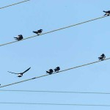
House Martins at Lethen, 1 August 2016 (Jack Harrison)
1/8/2016 Ringed Plover 47, Turnstone 4, Shelduck 2 Spey estuary (east side) Martin Cook

